

COAL PROJECT REPORT

Muhammad Shahmir 21K-3563

Khizer Nadeem 21K-4768

Kashmala 21k-3579

**Submitted to Sir Nadeem**

**SNAKE GAME USING ASSEMBLY LANGUAGE** 8086

**Abstract:**

We will be implementing the classic snake game using Assembly Language. The game features a snake, played using the keyboard. The snake begins at a fixed position and the player utilizes the WASD keys to move their snake throughout the console. Food appears on the screen which will make the snake bigger. If the player runs into the wall the game will end. The game will also feature 3 levels that is easy, medium and hard which will make the snake go faster thus increasing the difficulty for the player.

**Detailed Features:**

**Controls:**

|  |  |
| --- | --- |
| **KEY** | **ACTION** |
| W | Move Forward |
| A | Move Left |
| S | Move Backwards |
| D | Move Right |
| X | Exit the game |

**Snakes Movement Speed:**

* User may choose from three speed levels, level 1 to level 3, level 3 being the slowest.

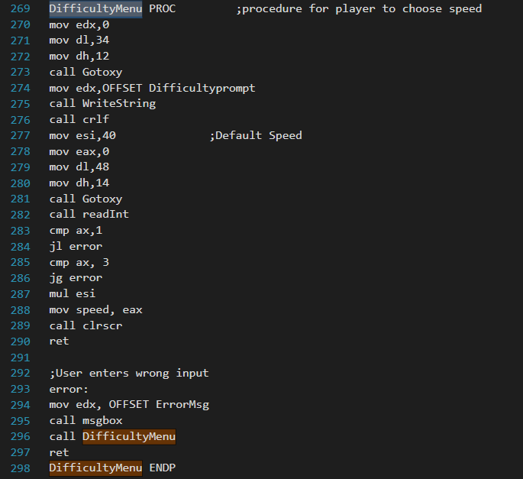

**Move Snake:**

* The head of the snake will be moved according to the user's last known input.
* The body of the snake will be moved to the coordinate of the unit before it.

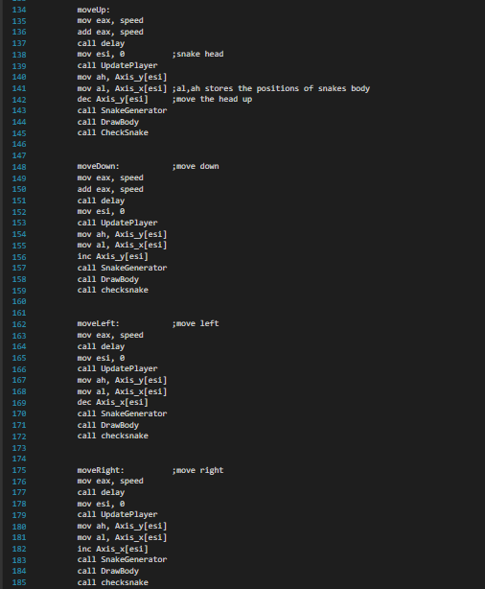

**Eating Food:**

* When the Snake moves, the coordinate of the head is compared with the coordinate of the coin to check whether the snake eats a coin
* When a coin is eaten, a new unit is added to the snake to lengthen the snake.
* The new tail is at the position of the old tail, a new tail is added according to the direction of the old tail

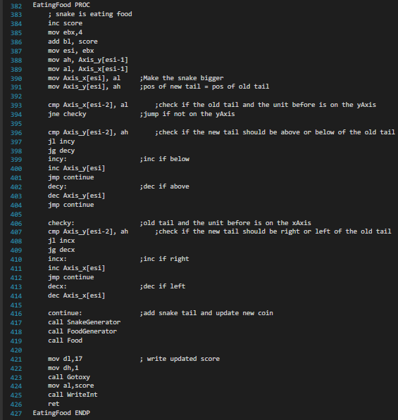

**Wall Collision Detection:**

* When the Snake moves, the coordinate of the head is compared with the coordinate of the wall to check whether the snake collides with the wall
* Snake dies when it collides with the wall

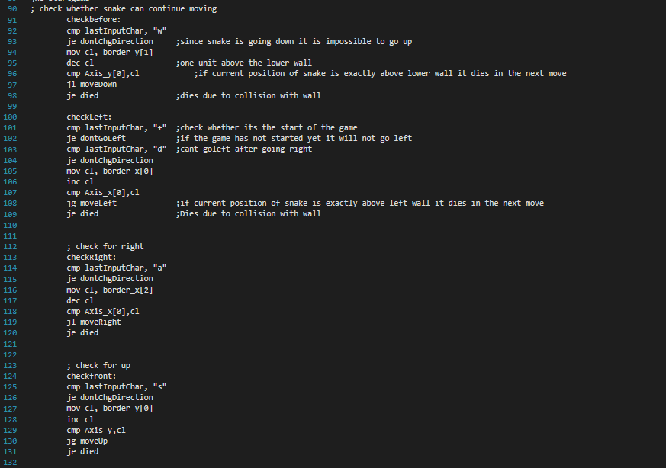

**Self-Collision Detection:**

* When the Snake moves, the coordinate of the head is compared with the coordinate of the coin to check whether the snake collides with itself
* Snake dies when it collides with itself

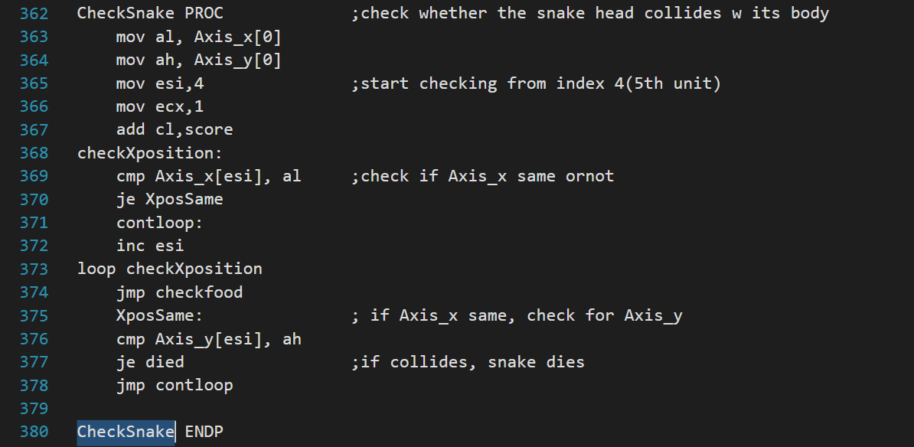

**Gameplay Screenshots:**

